Final report Project week

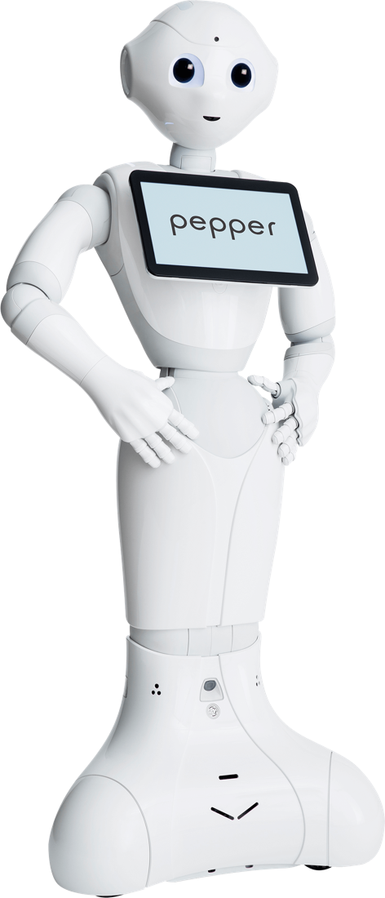

Case 22b: Digital innovation (Pepper)
By: Melvin Oonincx, Hao Guo, Grace Bekou Fomo Djongoum, Bas Geijs, Bogomil Dochev
Date: November 2021

Table of content
Group evaluation 3
Preparation 5
Approach 6
Results 6
Conclusion 7
Script: 7

Group evaluation

Daily reflection
Monday:
Even though we did not know each other we still got the work done the way we wanted and finished the PVA. We divided the tasks among the members of the team and followed the agreement we made.
In general, we had a tough time figuring out what we were going to accomplish. Besides that, we were also missing 2 members and there was no one that told us about this. Later, we got a new member in our team. We welcomed him in the group and he enjoyed it.
We could have used some more time to get to know each other better to take advantage of our qualities and we could have taken more initiative to make the planning with the other Pepper team about the robot schedule.
Tuesday:
We started on time, and everyone was there the entire day and we all checked in and out and we were all trying to work as a team.
Our Tuesday started with setting up the Pepper robot. Hao had installed the program that runs the pepper robot on his laptop and was ready to boot it. With the help of Frans, we got the robot working in around 10 minutes. In the first few minutes, we were quite impressed by the robot because of what he already did without any input. Then we got to work with the programming of Pepper. We tried different options in programming. We also looked online for tutorials on how Pepper works. This helped us quite a lot in order to get a basic understanding of the program within the robot. The tutorial was found by Bogomil. Grace took notes of what was happening and the progress we made. Melvin was giving input on how to test the robot and kept in contact with the teachers and the client. Hao was in charge of the programming and the testing of Pepper through his computer.
We got feedback on our project from Daphne.
Wednesday:
We were all in the room at the time we decided on Tuesday and Hao had a meeting in between but it did not slow down our progress and when he came back, we worked together on the project again, also today we checked out together.
We started today by looking into the script. In this we try to write what we want the robot to do for the final report. We found out that the screen is not working. We also found out that the robot does not really understand what you are saying if you have an accent. And this makes it hard to program the speaking. We got stuck in a loop that goes back to the start after every input. Bogomil worked on the poster.
Thursday:
On this day we decided to start a bit later because of the planning of when we can work with Pepper and everyone was on time besides Hao, he missed his bus and the check-in, but it was not a big deal because he could catch the hours later.
We started looking at the script and changed it according to the feedback we got, out focus was more on the report and poster so we have it all set for Friday. we also prepared Pepper so that we were able to show something on the presentation market. We also decided to put the robot outside of the room to attract people to test the robot for us and using their feedback, we were able to improve our script for Pepper.
Friday:
We are all on time before 10 and we started to prepare for the presentation market and using the morning to finalize the poster, also test the robot to make sure it will work the way we want it to work. Today we wrapped things up. Handed in everything before the deadline and the presentation market.

Feedback

Our first idea is for the robot to answer questions on the open day. The robot is supposed to reply and understand what a human was saying to him. We have tried many options that were already installed in the robot. We showed this to our client and got feedback from them. In this feedback they talked about what they like about our project and what can be improved. They talked about how to make the robot respond better. The feedback was that there might have been a lot of background noise, therefore, we had to try to test the robot in a quieter place. There it could hear us better because it wouldn’t have any background noise, which could potentially make it work better. They said you could make the robot interact by using the sensors. Some of them are placed on the head. We could use this to start a conversation with people that come into the school on the open day. We talked with the teacher about how we could improve our poster for the final presentation. In this we talked about how we could be more in depth about what we want to show and be more specific about how we want to promote the robot. After this we talked about the report to the teacher.

Examples aspects
Good aspects:

Less good aspects:

What we take away
Positive aspects that we will keep in the future:
- Respect between team members
- Keeping on the time schedule
Negative aspects that we will improve in the future:
- Use the strong point of the team members
- Working more efficiently

Preparation
We prepared ourselves before we started working with the Pepper robot. Firstly, we did research on what the robot can do and how we can achieve that. We watched some tutorials about that which helped us understand the fundamentals of working with the robot. For example, where the touch sensors on his/her/its body are or how we can program it to do different actions like movement, speaking, listening, or dancing.

Approach
Our approach of this project was to first work towards the between product that we described in the plan of approach. Our between product was a brief understanding of how Pepper works and how we can set it up so we can work with it. We would also like to have a program that the Pepper robot can perform which will help us explain what we accomplished. We will also make a conclusion on what is possible to do with the robot.
When we get the between product done by having an idea about what the Pepper robot is capable of doing, we can work towards our end goal. Our end goal is

Results
When testing the robot, we found out what Pepper can do.
What it can do:
- Talk
- Respond in talking
- Recognize people
- Look at people when they are talking
- Ask questions and have different responses following that question
- Walk with instructions
- Wave
- Talk in the direction of a human
- Talk and move at the same time
- Detect faces and then speak

We did some research on the Pepper robot and found things that the Pepper robot could do, but we were not capable of doing ourselves.
What should work:
- Speaking in other languages.
- Reading QR codes
- The movement
- The scripted response
When testing the Pepper robot we found some interesting problem cases regarding programming the robot.
Problem cases:
- The battery does not last that long. It can't stay alive the entire day without charging.
- The version of the Pepper robot is outdated and we were not able to update it. In this way we are missing some functionalities.
- The Pepper robot hardly recognize sentences, only key words
Our general idea of this project became much clearer when the testing was done.
From this point we started to work toward the end goal.

Script
To use make use of the Pepper robot in promotional activities on the HZ university of applied sciences we had to come up with a script. With this script the potential new students can have a simple interaction with the Pepper robot.
Intro
Student: Hello
Pepper: Welcome to the HZ, my name is Pepper and let us have some fun.
*dancing of pepper*

Body
Pepper: Okay thank you for waiting, what do you want to talk about? I can inform you about the education, school, teachers or projects.
Student Keywords: Education, School, Teachers and Projects.
Student: I want to know more about the IT education
Pepper: The IT education is located in Middelburg. The education is 4 years in which you get the knowledge to set you up for a career in the IT. You start this education by doing some standard things that every IT specialist needs to have the skills of.
Student: School
Pepper: This school is located in Vlissingen and Middelburg, it is quite new. At the moment, progress is being made for a new part of the building in Middelburg, which will be a laboratory.
Student: Teachers
Pepper: The are about 15 teachers in the IT department. Each one of them has a different skill which they will teach you, when you join the IT education.
Student: Projects
Pepper: At the ICT education we start working on project from the second semester of the first year. In these projects, the students work together with companies that want an ICT solution. In every single project there is a different working way to get to the end goal.

Ending
Student: Goodbye / Thank you
Pepper: Goodbye have a great day.
Student: *walks away*

*Saxophone dance*

At the end of this script the student will have some basic knowledge about the school and education.

Conclusion
In conclusion, the Pepper robot can be used for a lot of different goals and interactions, mostly for (future) students. In open days, a program could be developed in order to make Pepper pick up more key words, which would make it an interesting promotion and could get people hyped for a study at HZ, especially I(C)T. Future students will probably be excited for when they get to work with the robot and be able to program it.
Furthermore, it could be used as a “greeting machine” and answer frequently asked questions with the use of key words, as shown in the script. If this could be expanded, Pepper could answer these questions without the help from teachers, which could make them work on other things like grading and answering e-mails. This would improve the productivity of the school in general, and it would be nice for the person asking the question as they are being answered in a unique and innovative way.
Pepper is also able to move, which means it could probably guide students to their classrooms if they feel lost. We also feel like the robot is not being used enough at the moment and would like to see it gain some more functions, which could be done in a bigger project. That way, students at HZ, particularly from the I(C)T department could actively help their fellow students while having fun/earning EC’s at the same time.
However, we also encountered some problems while working with Pepper. The first is definitely voice recognition, because we had to repeat our words very often in order to test it. If not fixed, this could be very annoying for the user.
Another problem is that the hands of the robot sometimes got stuck, for example when it was dancing, and it could not get into the right position. This is definitely much less of a problem however, since it does not break any of Pepper’s main functions.
Finally, the version of Pepper we had to use was outdated, which meant we could not use the tablet on its torso. This meant there were several functions we simply couldn’t use, but if we were to get an updated version the robot would probably be able to do way more things and using it would be easier.
As for some other, bigger ideas, we could have Pepper connect to the internet to make it be able to answer even more questions from students, which could make workload for teachers even less and make them more focused. However, we could not get this to work in this short amount of time.
Another idea is to make the tablet work for another way of input. This would make the problem of rough voice recognition not a problem anymore, since it would be fairly easy to just input a word to make Pepper respond more easily. This would be especially handy for the open days, since there is a lot of background noise on those days.
In summary, there are a lot of functions for this robot and we feel like it would possibly be a good idea to buy more.

Bigger ideas:
Have Pepper guide potential students the way.
Have Pepper connected to the internet and let it answer questions.

References
Choregraphe Suite. (n.d.). Retrieved from doc.aldebaran.com: http://doc.aldebaran.com/2-5/software/choregraphe/index.html
Danaher, J. (2020). Welcoming Robots into the Moral Circle: A Defence of Ethical Behaviourism. Retrieved from link.springer.com: https://link.springer.com/article/10.1007%2Fs11948-019-00119-x
Jilles Smids, S. N. (2020). Robots in the Workplace: a Threat to—or Opportunity for—Meaningful Work? Retrieved from link.springer.com: https://link.springer.com/article/10.1007/s13347-019-00377-4
Pepper. (n.d.). Retrieved from www.softbankrobotics.com: https://www.softbankrobotics.com/emea/en/pepper
Schneider, E. (2018, August 10). Getting Started with virtual Pepper robot & Choregraphe. Retrieved from www.youtube.com: https://www.youtube.com/watch?v=ubMuqIF9yRY&ab_channel=ELKESCHNEIDER
Schofield, D. (2019, February 08). Learn Choregraphe - QiChat - Special Topics. Retrieved from www.youtube.com: https://www.youtube.com/watch?v=tqVbX5NWFdU&ab_channel=DanielSchofield

